Name:

Genomics and Bioinformatics
Bioinformatics Section
Quiz #1, April 4th 2005

Directions: You have 20 minutes to complete the quiz. This quiz is worth 4% of your total grade for the course. There are a total of 50 points distributed among six questions. Please provide your answers in the space given. Good luck.

(Question 1 – 20 points)

Provide an optimal alignment for the sequences MIIEFAH and MICIEAH. To do this, use the Needleman-Wunsch algorithm. All matches have a score of +2, mismatches have a score of +0, gap openings score -1 and gap extensions score +0. You must show the complete score matrix and alignment to receive full credit.

ANSWER:

MI-IEFAH
MICIE-AH

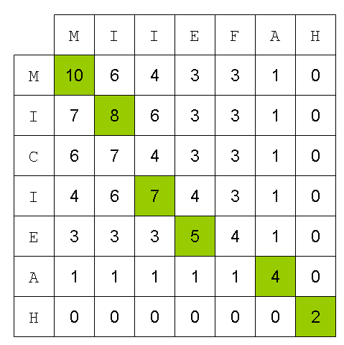

(Question 2 – 5 points)

What does it mean if I say an algorithm runs in time O(N²)?

ANSWER:
The run-time of the algorithm scales quadraticaly with the size of its input.

(Question 3 – 5 points)

Given 2 protein sequences that came from very divergent organisms, what is the better similarity matrix to use – PAM100, or PAM250?

ANSWER:
PAM250

(Question 4 – 10 points)

Name two reasons you might prefer modeling a multiple alignment motif with HMMs instead of with a regular expression.

ANSWER:
- Regular expressions have discrete probabilities for each position – HMMs can model more complicated distributions.
- Length of inserts can be probabilistically modeled.
- Residue emission probabilities can be modeled within the inserts.
Etc.

(Question 5 – 5 points)

What statistical distribution is used for calculating p-values from BLAST?

ANSWER:
Extreme value distribution

(Question 6 – 5 points)

Give an example of a progressive-alignment multiple sequence alignment algorithm.

ANSWER:
CLUSTAL

